**Tourism for Blog in Web Application**

**A project report submitted to**

**BHIMAVARAM INSTITUTE OF ENGINEERING AND TECHNOLOGY**

**In partial fulfillment of the requirements for the awarded of the degree of**

**BACHELOR OF TECHNOLOGY**

**IN**

**COMPUTER SCIENCE AND ENGINEERING**

**Submitted by**

**S. GANESH 21AP5A0503**

**K. PADMA 20AP1A0531**

**D.VARSHA 20AP1A0514**

**T.P.R.M.S.V. SUBBA RAO 20AP1A0544**

**Under the esteemed guidance of**

**Mr. U.S.V. VINOD**



**DEPARTMENT OF COMPUTER SCIENCE AND ENGINEERING**

**BHIMAVARAM INSTITUTE OF ENGINEERING AND TECHNOLOGY**

**Pennada, BHIMAVARAM-534243**

**Affiliated to JNTUK, KAKINADA and Approved by AICTE, NEW DELHI**

**(2020-2024)**

**BHIMAVARAM INSTITUTE OF ENGINEERING AND TECHNOLOGY**

**Pennada, Bhimavaram-534243.**

**Affiliated to JNTUK, KAKINADA and Approved by AICTE, New Delhi**

**DEPARTMENT OF COMPUTER SCIENCE AND ENGINEERING**

**CERTIFICATE**

**This is to certificated by the project work entitled “Tourism for Blog in Web Application” is the bonafied work done by S. GANESH (21AP5A0503), K. PADMA (20AP1A0531), D. VARSHA (20AP1A0514) ,T.P.R.M.S.V. SUBBA RAO (20AP1A0544) in the department of COMPUTER SCIENCE AND ENGINEERING during the year 2020-2024. This work has been carried out under my guidance and super vision the result embodied in this project report have not been submitted in any university of organization for the award of any degree .**

**Internal Guide Head of the Department**

**Mr. U.S.V.VINOD Mr. U.S.V.VINOD**

**Associate Professor Associate Professor**

**Department of CSE Department of CSE**

**DECLARATION**

We have by declare that project report entitled **“Tourisim for Blog in Web Application”** is genuine project work carried out by us in Bachelor of Degree **COMPUTER SICENCE AND ENGINEERING** Degree course of **JAWAHARLAL NEHRU TECHNOLOGICAL UNIVERSITY, KAKINADA** and has not been submitted to any other courses (or) university for award of degree of us

**Date:**

**Place:**

**ACKNOWLEDGEMENT**

In the accomplishment of this project successfully, many people have best owned upon me their blessings and the heart pledged support, this time I am utilizing to thank all the people who have been concerned with this project.

I would like to thank my **guide and project coordinator**, whose valuable guidance has been the ones that helped me to patch this project and make it full proof success.

I would like to thank my **principal Dr. K. Suresh, Bhimavaram Institute of Engineering and Technology College**, whose encouragement and guidance helped me for the fulfillment of the project

Then I would like to thank my **Head of the Department CSE Mr. U.S.V. Vinod** who have helped me with their valuable suggestions and guidance has been very helpful in various phases of the completion of the project.

Last but not the least I would like to thank my classmates who have helped me a lot.

By: S.GANESH

K.PADMA

D.VARSHA

T.P.R.M.S.V. SUBBA RAO

**ABSTRACT**

Blog is a communication tool that plays a key role in a web application. Use of blogs has resulted in a paradigm shift in the way a web application interacts with the customer. During the development of web application, there is a need to elicit and specify the requirements for the blogging functionality. In this study, we present a requirements checklist for the blog, from the perspective of integrating the blog in a web application. We follow the use case-based approach for identifying the software requirement for the blog. The requirement checklist helps both the web application and the developer during the requirement elicitation of the blog’s software. The checklist is also useful during the testing phase for the validation and verification of the blog functionality.

**CONTENTS**

|  |  |
| --- | --- |
| **S.NO** | **TITLES** |
|  | **ABSTRACT** |
| **1.** | **INTRODUCTION**  1.1 User of blogs  1.2 Structure of blogs  1.3 Blogs Home  1.4 Blogs Parameters  1.5 Blog Dashboard |
| **2.** | **REQUIREMENTS**  2.1 Software Requirement  2.2 Hardware Requirement |
| **3.** | **USE CASE DIAGRAMS**  3.1 Home Page  3.2 Registration Form  3.3 Login Page  3.4 Case Study |
| **4.** | **BENEFITS OF BLOG APP**  4.1 Advantages  4.2 Disadvantages |

**INTRODUCTION**

Web applications are an integral part of our day-to-day work-be it hotels, sports, news, business, medicine or education. In a competitive world that promotes global access to services, there is an increasing need to reach out to the customers and provide them with regular updates and information. Nowadays, blog is an essential component of a web application.

Blog is an important social networking tool included in a web application, to facilitate interaction and collaboration with the users. For a web application, it is an important part of online marketing. Blog in a web application is used for promoting products and services, writing articles, providing product updates, educating user. Blog facilitates communication and interaction with the user to share knowledge and expertise.

A blog is included in a web application (Leary, 2010) in either of the two ways hosted on the server of a blog publishing application like WordPress (Hayder and Silver, 2009), or installed on the server space of the web application. Generally, the second option of installing blog software in own server space is the preferred choice of a web application. It is not a standard practice to write code for the blog. The free themes and database from the blog publishing application are used along with plug-ins, which are adapted for the web application. Some web applications may also prefer to write their own code for the blog software.

There is a need to specify the software requirements for the blog, both, when an existing blog is adapted or a new one is developed. Support pages exist at the blog publishing application sites that describe the functionality of the different features of the blog. The functionality of the blog is listed, when a new blog is developed. But none of them address the issue of the software requirement specification for the blog.

In this study, we focus on creation of software requirement specification for the blog, for use during the development of a web application. Our aim is to help the web application to specify the software requirement for blog, by choosing the desired functionality.

Here, we present a blog software requirement checklist, which facilitates in selecting the requirement of the blog for a web application. The requirement checklist is provided for the different components of the blog, namely, Blog Home, Blog Dashboard and Blog Parameters. The requirement checklist is for use both by the web application and the developer and facilitates in identifying the functionality required in the blog’s software. During the requirement phase of software development, functionality that is needed for the blog in a web application can be selected from the checklist.

For formulating the requirement checklist, we performed a study of three popular blog publishing software- WordPress (2003). We use the use case-based approach to identify the software requirement for the blog.

We identify actors who use the software, components of software and functionality of each component of the software. We classify the components based on the interaction of actors with the blog’s software.

Since blog is a standard tool, generic in nature, the requirement checklist relieves the web application and the developer from the task of specifying the software requirements for the blog afresh. A web application may choose all or a part of the functionality specified in the checklist. The checklist is for use during the software requirement phase and also during the validation and verification of the requirements during the testing phase. The requirement checklist presented here can be easily updated to include any new functionality, feature or an option.

In this study, Material and Methods provides an overview of the methods used during our research. Results describes the users, the structure and the requirement checklist of blog in web application in detail. In the Discussion, the benefits of the checklist are enumerated. Also, in this section, two examples on which we have applied the checklist and the survey of related work are illustrated. Finally, the conclusion is stated in the conclusion.

**1.1 Users of Blog**

The software for blog in a web application has different kinds of users. The users interact with the blog in different ways. We identify three users or actors of the blog’s software in a web application, as follows:

* Web Application is the software in which the blog’s software is integrated. The web application interacts with the blog’s software for defining the various settings and parameters of the blog. This includes the setting for the look and feel of the blog and the features to be included in the blog.
* Administrator is any person performing the task of updating and maintaining the blog. The administrator has full rights for maintenance of the blog. The administrator can perform tasks like edit post, new post, delete post. The settings and parameters for blog and post is also a task of the administrator.
* Visitor is a user who visits the blog in a web application via the Internet. The visitor views blog home that contains the blogs and posts which the user can read. The visitor can perform various tasks like, comment on post, like post or share post.

The interaction of a web application with the blog’s software aims at listing the desired parameters to be included in the blog when incorporating it in a web application. The web application interacts with the blog to set the various parameters only once, when the blog is to be included in the web application.

**1.2 Structure of Blog**

The users of the blog’s software interact with different components of the blog. We classify the blog in a web application, based on the interaction of users with the blog’s software. The blog’s software is classified in three broad components as follows:

* Blog Home is the view for visitor
* Blog Parameters is the view for web application
* Blog Dashboard is the view for administrator

**1.3 Blog Home**

Blog home is the main homepage of the blog, which is visible to a visitor, in a web application. It is hierarchical in structure. Blog title is at next level in the hierarchy. The blog home consists of several blog titles. Blog title is the homepage for individual blogs. Further, each blog title may have many posts, pages and media within them. Header, Footer, Content Area and Sidebar (Reeder and Scoleri 2007). For any page in the hierarchy, the header and footer may display default menu of the web application or a customized menu. Sidebar contains various widgets which are used for interaction with the blog. All pages in the hierarchy differ in only the content area, with the header, footer and sidebar area having the same information for all.

Blog home displays the list of latest posts that have been published across all the blog titles, in the content area. Each post contains a post title, timestamp and few starting lines or excerpt. It also contains various options, like, share a post, subscribe to a post and like a post. There is only one page for the blog home.

Blog title is the homepage for the individual blog present in the blog home. In its content area, list of latest posts that have been published under the blog title are displayed. Posts in blog title are displayed in the same format as in blog homepage. There is one blog title page for each entry in the blog home.

Post is the entries that are made in a blog title. The content area of the post displays the following:

* Name of the post, photo header, post title and the author’s name along with the timestamp
* Content of the post
* Various options, like, share post, like post, view tag
* A comment section where a visitor can comment on the post, share it and rate it.

Pages and media have a structure similar to that of the post. Post is dynamic in nature, but page is of static nature and is not listed by date. Pages do not use tags or categories. An About page is the classic example of a page. In case of media, instead of post title, the filename of the media file is displayed. The content is replaced by a link to the media file.

**1.4 Blog Parameters**

Blog parameter is that part of blog which is used by the web application to define the look and feel of the blog and the features of the blog’s software. The features are defined via various options available to the web application. Some of the parameters decided by the web application are:

* Number of posts that can be displayed on the homepage
* Size of the posts
* Format in which the time and date will be displayed
* Language in which the blog can be written
* Who can comment on the blog like registered users
* Will the comments be moderated or approved directly

The look of blog is defined by deciding the ‘theme’, that is to be used for the blog. The theme of the blog can be either same as of the web application or can be customized.

The blog parameters define the functionality that will be available in the blog’s software.

**1.5 Blog Dashboard**

Blog dashboard is the interface provided to the administrator for maintaining and updating the blog in a web application. Blog dashboard contains a list of blogs titles present in the web application. With each blog title is associated a set of tabs to maintain and update it. The administrator uses the tabs to maintain the posts, page, media, link, comment, ratings, statistics, settings and for maintenance.

Post tab provides the administrator with options for creating new posts, editing posts, deleting post. Similar options are provided for page and media by page tab and media tab, respectively. Comment tab is used by administrator for approving/disapproving the comment, marking it spam. Links tab allows add, delete and edit feature for the links present in the blogroll widget. Rating tab is used for viewing the ratings of post, page and comment. It is also used for defining setting for ratings. Maintenance tab is used for maintaining the blog title. Using it, the administrator can add a new blog title, delete a blog title, import/export blog title. Stats tab provides statistics for the blog titles present on the web application. It also provides the stats for individual posts and pages of all the blog titles. The setting tab is similar to the one present in blog parameter. The administrator can change the settings when needed.

**REQUIREMENTS**

**2.1 Software requirements:**

Front end Technologies : HTML5, CSS3, BOOTSTRAP

Web Browser : Google Chrome, Microsoft Edge, Internet Explorer

Designing : Rational Rose

IDE : Visual Studio

Operating System : windows 10

**2.2 Hardware requirements:**

Processor : Intel core I3

Ram : Minimum 4gb

Hard Disk : Minimum 256gb

**USE CASE DIAGRAMS**

**Home Page:**

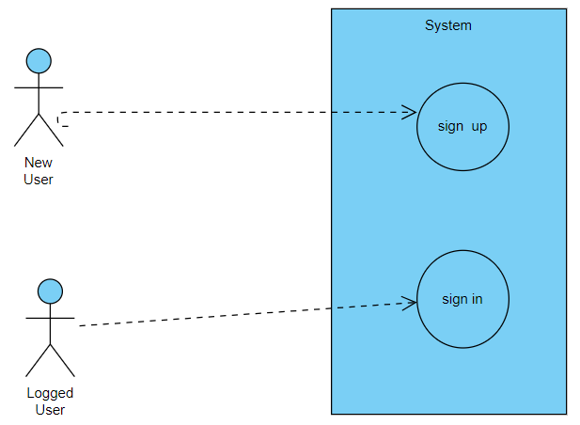

**3.1 Registration Form**

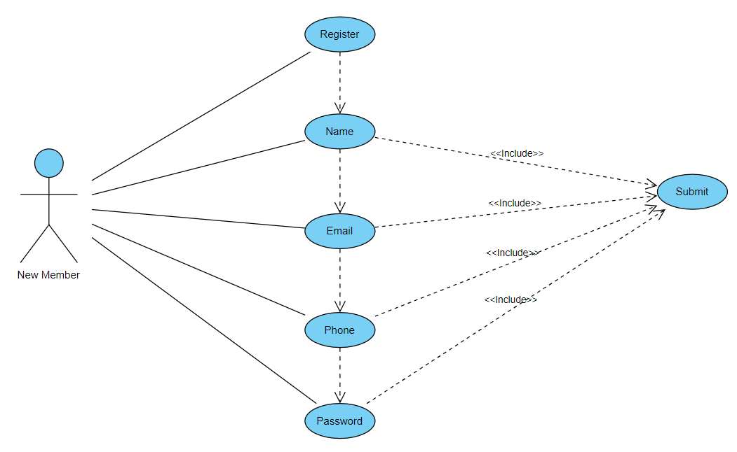

**3.2 Login Page**

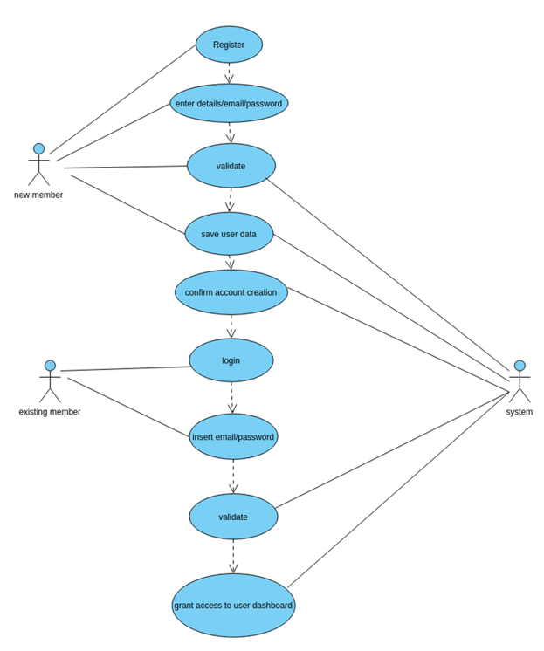

**CODE**

HOME . HTML :

<!DOCTYPE html>

<html lang="en">

<head>

    <style>

        *{

  margin:0;

  padding:0;

}

    body{

        background-image:url('BALI.jpeg.jpg');

        height:100vh;

        background-size: cover;

        background-position: center;

        overflow-y: hidden;

    }

    .login{

        width: 350px;

        padding: 150px;

        margin: auto;

    }

    .form{

        position: relative;

        z-index: 1;

        width: 90%;

        margin: 10px;

        padding: 20px;

        padding-left:170px;

         }

    .form button{

        front-family:"Roboto",sans-serif;

        outline:1;

        background-color:orange;

        cursor:pointer;

        border: 10px;

        width: 50%;

        margin: 15px;

        padding: 15px;

        box-sizing: border-box;

        font-size: 16px;

        text-align: center;

        border-radius:7px;

        }

    form button[type="submit"]:hover

     {

      color:red;

     }

    button1

     {

        background-color: coral;

    }

    .form h1{

        font-size: 30px;

        }

    </style>

  </head>

    <body>

      <div class="login">

       <div class="form">

    <form class="form">

        <h1><u>VISIT OUR BLOG</u></h1>

       <button  type="submit" >

        <a href="login.html">

        Sign in</button>

        </a>

      <button  type="submit">

        <a href="registration.html">Sign up</a>

    </button>

       <p class="small mb-0">Don't have account?<a href="registration.html">Create an account</a></p>

        </form>

       </div>

        </div>

     </body>

    </html>

**HOME PAGE :**

**3.3 Case Study**

The requirement checklist for the blog’s software has been applied to five different web applications having blog software. Econsultancy (1999); Milestone (1998); Yahoo (1995) and Movie blog (2001) are the web applications relating to sports, consultancy, hospitality, news and movie, respectively, whose blog software we have chosen for the study, we focus on the functionality provided to any visitor of a blog, in the different blog software and use our checklist for validation.

ESPNcricinfo.com is a leading cricket website providing live ball-by-ball coverage of all test matches, one-day matches and cricket related news.

The site includes blogs written by some of the world’s best cricketers and cricket writers. Econsultancy.com is a community for digital marketing and e-commerce professionals, who interact to sharpen their strategy, source suppliers, compare notes and to help each other out. It provides reports, events, online resources and training programs to help their members. Milestone internet marketing provides internet marketing solutions for the lodging, hospitality and travel industry and specializing in hotels, resorts, bed and breakfasts, restaurants. They design websites, market and promote the client properties on the Internet. Yahoo! News is the news service provided by Yahoo Inc. It provides news from all over the world in areas, like, entertainment, sports technology and health. The Movie Blog is a blog about movies, started by John Campea. Thought and opinions on various movies and movie stars are posted here.

Our requirement checklist is applied to the Blog Home of the blog’s software for the post, blog title and blog home components. We discuss some of the key findings, here. In post, we find that reply to a comment option is provided by yahoo news blog and movie blog only. Also, yahoo news blog is the only one providing the option of rating a comment. Tag cloud is included only in econsultancy and milestone internet. In Blog Title, we note that movie blog is a single author blog, so the option of Blog Title does not exist. In the Blog Home components, we find that Blogroll is only provided by movie blog. The archive option is provided by cricinfo, milestone and movieblog, but not by Yahoo and econsulta

**BENEFITS OF BLOG APP**

**4.1 ADVANTAGES**

Blogs offer a wide range of advantages for individuals, businesses, and organizations. Here are some of the key advantages of maintaining a blog:

1. **Content Sharing and Information Dissemination**: Blogs allow you to share valuable information, insights, and expertise on a particular subject. This can help educate and inform your audience, positioning you as a thought leader in your field.
2. **Audience Engagement**: Blogs provide a platform for direct interaction with your audience. Readers can leave comments, ask questions, and engage in discussions, fostering a sense of community around your content.
3. **Search Engine Optimization (SEO)**: Regularly updating your blog with relevant and high-quality content can improve your website's search engine rankings. Search engines tend to favor websites that consistently provide fresh and valuable content, driving more organic traffic to your site.
4. **Brand Building**: A blog can contribute to building your brand's online presence and reputation. Consistently delivering valuable content helps establish your expertise and credibility within your industry.
5. **Lead Generation**: By offering valuable content, you can attract potential customers and clients to your website. This content can act as a lead generation tool, capturing the interest of visitors and guiding them through the sales funnel.
6. **Monetization Opportunities**: Blogs can be monetized through various methods, such as displaying ads, affiliate marketing, sponsored posts, and selling digital products or services. This can provide an additional stream of income for individuals and businesses.
7. **Flexible Publishing**: Blogs allow for flexibility in publishing frequency and content format. You can publish articles, guides, infographics, videos, and more, catering to different types of audience preferences.
8. **Showcasing Creativity**: Blogs provide a creative outlet to express ideas and opinions. Whether you're a writer, photographer, artist, or any other creative professional, a blog can serve as a platform to showcase your work.
9. **Networking and Collaboration**: Blogging can connect you with others in your industry or niche. Collaborations, guest posts, and cross-promotion opportunities can arise from your interactions within the blogging community.
10. **Personal Development**: Maintaining a blog can help you improve your writing skills, critical thinking, research abilities, and time management. Over time, you'll likely see growth in your abilities as a communicator and content creator.
11. **Archiving and Documentation**: Blogs serve as an organized archive of your thoughts, experiences, and expertise. This can be valuable for personal reflection, reference, or even historical purposes.
12. **Feedback and Improvement**: Through comments and engagement, you can receive feedback from your audience. This feedback can help you refine your content and tailor it to better meet the needs and interests of your readers.
13. **Cost-Effectiveness**: Starting a blog is relatively low-cost compared to other marketing and communication strategies. Many platforms offer free or affordable hosting options, Overall, a well-maintained blog can offer numerous benefits that contribute to personal, professional, and business growth. However, it's important to note that achieving these advantages requires consistent effort, high-quality content, and a clear understanding of your target audience's needs and preferences.

**4.2 DISADVANTAGES**

While blogs offer a wide range of advantages, they also come with some potential disadvantages. Here are a few disadvantages to consider when starting or maintaining a blog:

1. **Time and Commitment**: Consistently producing high-quality content takes time and effort. Writing, researching, editing, and promoting your blog posts can become a significant time commitment, especially if you're aiming for regular updates.
2. **Content Quality and Consistency**: Maintaining a consistent level of quality in your content can be challenging. If you're unable to maintain the same standard of writing or research in every post, it might impact your credibility and reader engagement.
3. **Initial Lack of Traffic**: Building an audience and driving traffic to your blog can be difficult, especially in the beginning. It may take time before you start seeing significant traffic or engagement, which can be discouraging for some bloggers.
4. **Technical Challenges**: Setting up and managing a blog involves dealing with technical aspects like domain registration, web hosting, content management systems, and potential technical issues. If you're not tech-savvy, these challenges can be frustrating.
5. **Monetization Complexity**: While blogs can be monetized, generating significant income from a blog can be complex and require substantial traffic and strategy. Monetization methods like ads, affiliate marketing, and sponsored posts often require careful planning and optimization.
6. **Oversaturation**: Many niches and topics have a high number of blogs and content creators. Standing out and attracting an audience in oversaturated niches can be particularly challenging.
7. **Negative Feedback and Trolls**: Opening your content up to the public can expose you to negative feedback, criticism, and even trolling. Dealing with negative comments and maintaining a positive online presence can be emotionally taxing.
8. **Writer's Block**: Generating fresh and engaging content ideas on a consistent basis can lead to writer's block. It can be frustrating when you're struggling to come up with new topics to write about.
9. **Lack of Immediate Financial Returns**: It can take a while before you start seeing any financial returns from your blog, especially if you're relying on methods like ad revenue. This lack of immediate gratification can be discouraging for some bloggers.
10. **Content Theft and Plagiarism**: Unfortunately, plagiarism and content theft are risks when you publish online. Your original content could be copied and used without your permission, which can be both frustrating and legally complex to address.
11. **Maintenance and Updates**: Blogs require regular maintenance, including software updates, security measures, and managing plugins or extensions. Neglecting these tasks can lead to technical issues or security vulnerabilities.
12. **Privacy Concerns**: Sharing personal information or experiences on a blog can compromise your privacy. It's important to be cautious about the type and amount of personal information you share online.
13. **Long-Term Commitment**: To reap the benefits of a blog, you need to commit to it over the long term. Many blogs are abandoned after a short period due to factors like lack of time, motivation, or results.

It's important to weigh both the advantages and disadvantages of starting a blog before diving in. While the potential benefits are significant, it's essential to be aware of the challenges you might encounter and be prepared to address them effectively.

**CONCLUSION**

We present a software requirement checklist for the blog in a web application. It facilitates in specifying the requirements during the software requirement phase. It is also used during the testing phase for verification and validation of the blog’s software requirements. Since the checklist requires the user to choose and select the desired functionality and features for the blog in a web application, it eases the task of specifying the requirements for the blog’s software. The requirement checklist can be updated easily to add new features and function